**Lab4. Creating Procedures**

1. Create at least 4 procedures for your database. You may use the anonymous blocks you created in Lab 2 as a basis.
2. At least 3 procedures must be with parameters.
3. During the defense you must show the execution of the procedures.

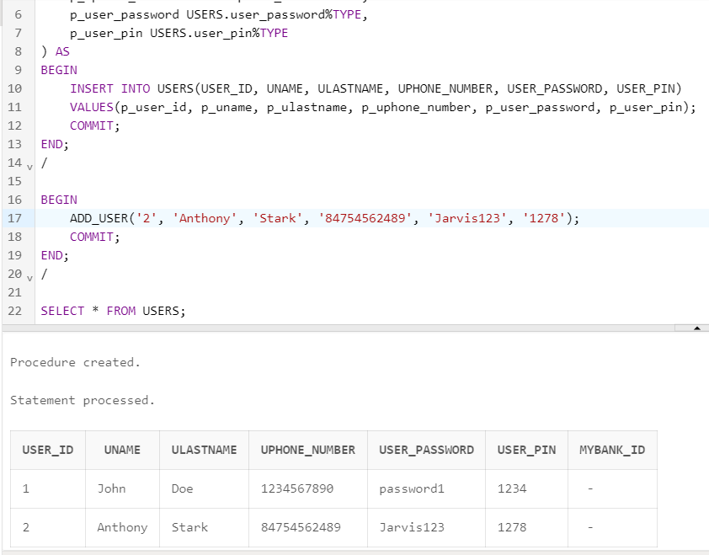

CREATE OR REPLACE PROCEDURE ADD_USER (

p_user_id USERS.USER_ID%TYPE,

p_uname USERS.UNAME%TYPE,

p_ulastname USERS.ULASTNAME%TYPE,

p_uphone_number USERS.uphone_number%TYPE,

p_user_password USERS.user_password%TYPE,

p_user_pin USERS.user_pin%TYPE

) AS

BEGIN

INSERT INTO USERS(USER_ID, UNAME, ULASTNAME, UPHONE_NUMBER, USER_PASSWORD, USER_PIN)

VALUES(p_user_id, p_uname, p_ulastname, p_uphone_number, p_user_password, p_user_pin);

COMMIT;

END;

/

BEGIN

ADD_USER('2', 'Anthony', 'Stark', '84754562489', 'Jarvis123', '1278');

COMMIT;

END;

/

SELECT * FROM USERS;

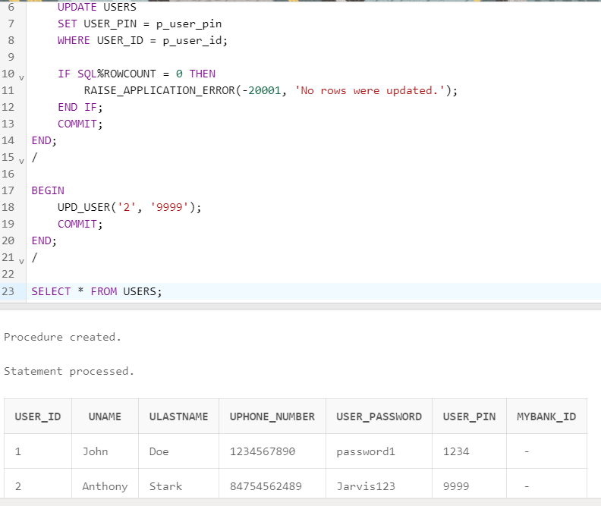

CREATE OR REPLACE PROCEDURE UPD_USER(

p_user_id USERS.USER_ID%TYPE,

p_user_pin USERS.USER_PIN%TYPE

) AS

BEGIN

UPDATE USERS

SET USER_PIN = p_user_pin

WHERE USER_ID = p_user_id;

IF SQL%ROWCOUNT = 0 THEN

RAISE_APPLICATION_ERROR(-20001, 'No rows were updated.');

END IF;

COMMIT;

END;

/

BEGIN

UPD_USER('2', '9999');

COMMIT;

END;

/

SELECT * FROM USERS;

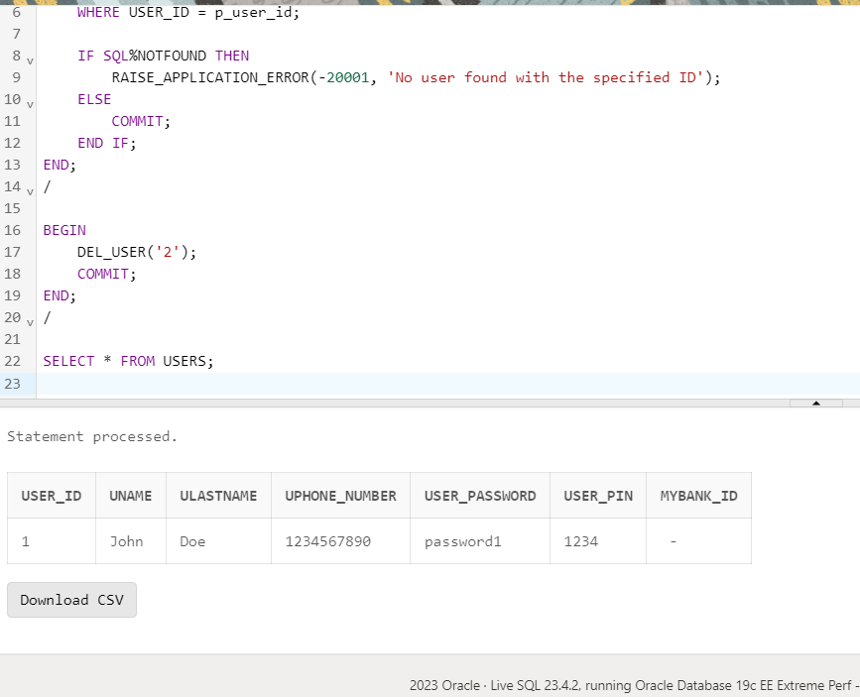

CREATE OR REPLACE PROCEDURE DEL_USER (

p_user_id USERS.USER_ID%TYPE

) AS

BEGIN

DELETE FROM USERS

WHERE USER_ID = p_user_id;

IF SQL%NOTFOUND THEN

RAISE_APPLICATION_ERROR(-20001, 'No user found with the specified ID');

ELSE

COMMIT;

END IF;

END;

/

BEGIN

DEL_USER('2');

COMMIT;

END;

/

SELECT * FROM USERS;

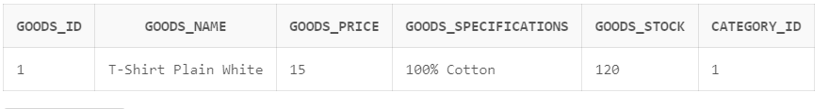

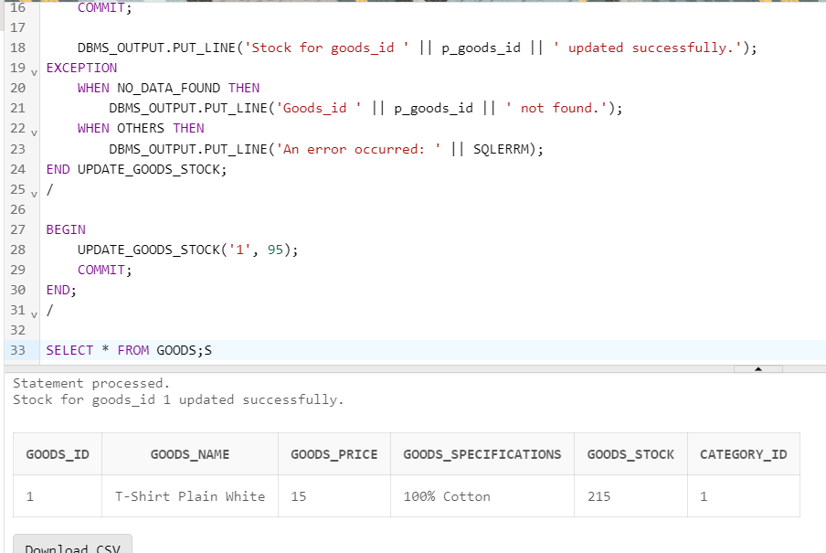

CREATE OR REPLACE PROCEDURE UPDATE_GOODS_STOCK(

p_goods_id IN GOODS.GOODS_ID%TYPE,

p_stock_change IN NUMBER

) AS

v_current_stock NUMBER;

BEGIN

SELECT GOODS_STOCK

INTO v_current_stock

FROM GOODS

WHERE GOODS_ID = p_goods_id;

UPDATE GOODS

SET GOODS_STOCK = v_current_stock + p_stock_change

WHERE GOODS_ID = p_goods_id;

COMMIT;

DBMS_OUTPUT.PUT_LINE('Stock for goods_id ' || p_goods_id || ' updated successfully.');

EXCEPTION

WHEN NO_DATA_FOUND THEN

DBMS_OUTPUT.PUT_LINE('Goods_id ' || p_goods_id || ' not found.');

WHEN OTHERS THEN

DBMS_OUTPUT.PUT_LINE('An error occurred: ' || SQLERRM);

END UPDATE_GOODS_STOCK;

/

BEGIN

UPDATE_GOODS_STOCK('1', 95);

COMMIT;

END;

/

SELECT * FROM GOODS;

Questions:

1. Define a procedure in PL/SQL
2. Describe the functionality of procedures
3. What types of parameters exist?
4. Explain the functionality of IN parameters
5. Explain the functionality of OUT parameters
6. Explain the functionality of IN OUT parameters
7. What are formal parameters?
8. What are actual parameters?
9. What types of notations for passing actual parameters exist in PL/SQL?
10. Describe positional notation for passing actual parameters
11. Describe named notation for passing actual parameters
12. Describe mixed notation for passing actual parameters